RESOLUTION NO.__________

RE: CERTIFICATE OF APPROPRIATENESS UNDER THE
PROVISIONS OF THE ACT OF THE PENNSYLVANIA
LEGISLATURE 1961, JUNE 13, P.L. 282 (53
SECTION 8004) AND BETHLEHEM ORDINANCE NO.
3952 AS AMENDED.

WHEREAS, it is proposed to install lettering on the front window at 401 E. Fourth St.

NOW, THEREFORE, BE IT RESOLVED by the Council of the City of Bethlehem that a Certificate of Appropriateness is hereby granted for the work.

Sponsored by: (s)

(s)

ADOPTED BY COUNCIL THIS DAY OF

(s)
President of Council

ATTEST:

(s)
City Clerk

HISTORIC CONSERVATION COMMISSION

CASE # 524 – It is proposed to install lettering in the front window at 401 E. Fourth St.
OWNER/APPLICANT: Kala Shanmugam

The Commission upon motion by Mr. Lader seconded by Mr. Loush adopted the proposal that City Council issue a Certificate of Appropriateness for the proposed work described herein:

- The proposal to install lettering in the front window at 401 E. Fourth St. was presented by Kala Shanmugam.

- The proposed sign will have 2” white vinyl letters reading “B.Y.O.B.” on the outside of the window to the right side of the entrance.

- The sign will be placed in the left bottom corner of the operable section of the window.

- A temporary sign placed on the building without HCC approval must be removed.

- The proposed motion was unanimously approved.

CU: cu
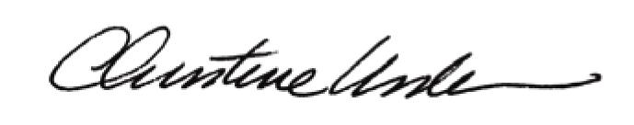

By:

Date of Meeting: November 17, 2014 Title: Historic Officer

